**KEOKUK UNION DEPOT FOUNDATION COMPLETES RESTORATION OF THE TRACKSIDE CANOPY**

**Keokuk, Iowa, September 21, 2022--** Between the Keokuk Union Depot and the railroad tracks is the completely restored trackside canopy reflecting its elegant 1891 appearance as designed by renowned Chicago architects Burnham & Root. The canopy has returned to the original color scheme, which blends beautifully with the Depot’s restored tile roof and eaves.

The restoration was overseen by historic preservation consultant and project manager Neal Vogel, Principal of Restoric, LLC, who grew up in Keokuk. Quincy Industrial Painting of Quincy, IL performed the delicate work of removing decades of rust and multiple layers of paint on the superstructure and underside of the canopy, as well as priming the areas to be painted.

Overall, the original structure of cast iron and corrugated steel was in remarkably good condition. Three of the eleven footings holding the trusses supporting the canopy (also known as a train shed) were damaged beyond repair and had to be reproduced from a mold taken from another footing.

Vogel conducted research indicating that the Depot’s turtleback canopy is the last surviving train shed of its kind and era still intact in the United States. Architectural drawings and pictures exist of similar structures for stations on the Chicago “L” and Illinois Central’s stations on Chicago’s lakefront, the Kansas City Union Depot and Detroit’s Fort Street Union Depot, but none remain. His research culminated in a presentation to the Construction History Society of America at its 7th Biennial Conference, giving significant national exposure to the restoration of Keokuk Union Depot. He will present his findings at the Depot on October 2 at 3 PM.

Many local individuals helped with painting the structure, performing welding, and installing period lighting fixtures. These individuals include Jordon Barnes, Damon Cackley, Jay Burton, Matt Eaton, Caleb Atterberg, Colton Atterberg, Woodie Brasil, Eli Riddle, Joe McNally, Jaren Wade, Mark Stanley (welding), and John Symmonds (lighting). All of the industrial epoxy coatings and supplies were purchased through Sherwin Williams in Keokuk, which made great efforts to provide sufficient materials when needed during supply shortages due to the pandemic.

The Keokuk Union Depot Foundation paid for the canopy project with part of the donations made so far by approximately 200 supporters toward the 2020 Jeffris Family Foundation Challenge Grant Capital Campaign. The recently begun second phase of the $825,000 Jeffris project is restoration of the waiting room exterior masonry, for which the Depot Foundation recently received a $50,000 grant from the State Historical Society of Iowa, Historical Resource Program. By raising $550,000 by June 30, 2023 the Depot Foundation will earn the award of the $275,000 Jeffris grant. Including the recent state grant, as of August 31, 2022 the Depot Foundation has raised $338,000 toward the Jeffris match. Contributions to the capital campaign may be sent to KUDF, P.O. Box 463, Keokuk, IA 52632.

The waiting room exterior masonry project is proceeding along with restoration of the exterior masonry of the adjacent central tower section, which is the subject of a separate grant to the City of Keokuk by a Paul Bruhn Historic Revitalization Grant from the Historic Preservation Fund administered by the National Park Service, Department of the Interior. When the exterior masonry is completed, the third and final phase of the current project—restoration of the waiting room interior—will begin.

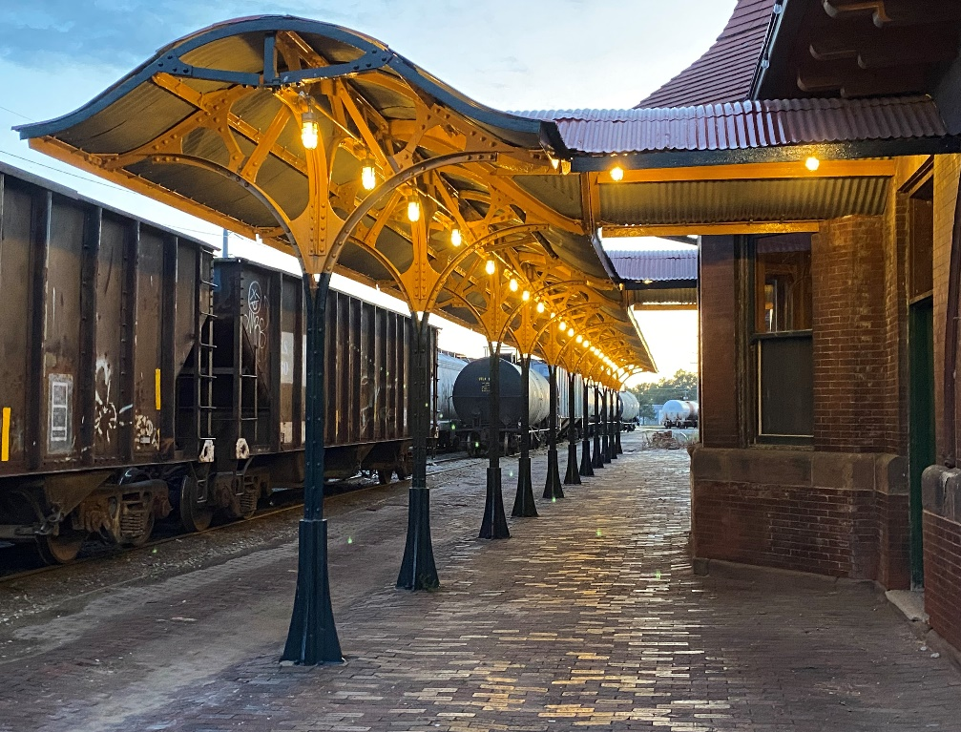

Photo by Neal Vogel

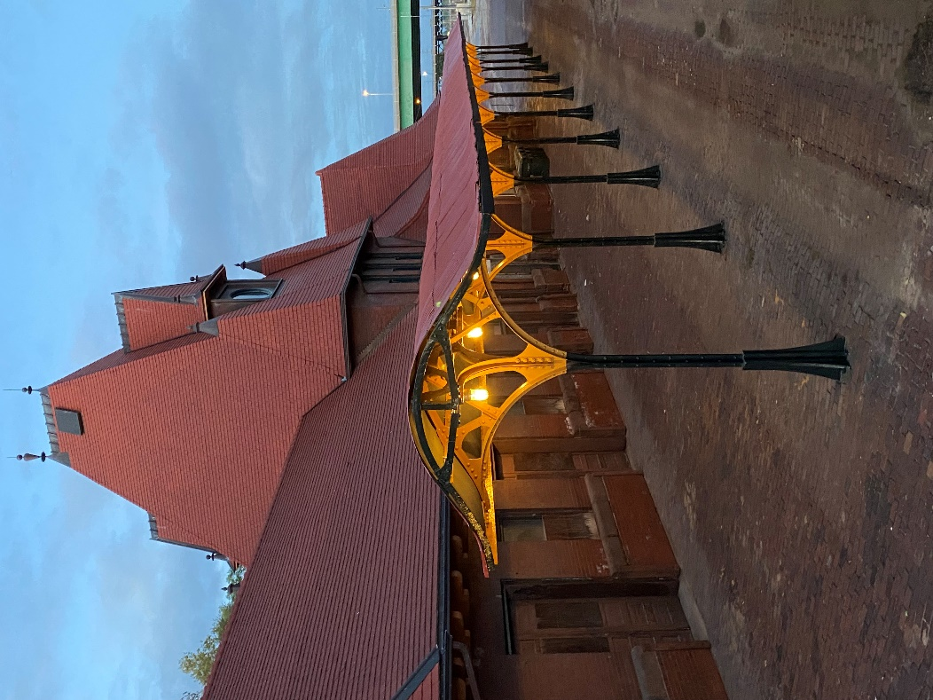

Photo by Neal Vogel