Form | Date | Time | Train # | Order # | Recipient | Details
Clearance Form A | 1968/01/23 | 0245 | 42 |  | C&E No 42 at Ravenna | 8 orders: 57 1 8 9 602 618 624 628
Form 19 | 1968/01/22 | 2139 | 42 | 57 | C&E No 42 at Ravenna | No 43 has right over No 42 Lincoln to CTC Ravenna
Form 19 | 1968/01/23 | 0030 | 42, 78 | 1 | C&E No 42 at Ravenna  C&E No 78 at Ravenna | No 78 run ahead of No 42 CTC Ravenna to Cushman
Form 19 | 1968/01/23 | 0214 | 42 | 8 | C&E No 42 at Ravenna | No 42 Eng 9969 meet Extra 109 West at Aurora  No 42 take siding
Form 19 | 1968/01/23 | 0216 | 42 | 9 | C&E No 42 at Ravenna | No 42 Eng 9969 meet No 75 Eng 558 at Utica  No 42 take siding
Form 19 | 1968/01/01 | 0001 |  | 602 | C&E Eastward trains at Ravenna | Sidings at Waco Hampton Abbott and St Michael blocked with cars
Form 19 | 1968/01/04 | 2104 |  | 618 | C&E Eastward trains at Ravenna | At Grand Island do not exceed 10 MPH over Union Pacific crossing at M 96.08 Monday through Friday 730 AM until 430 PM  25 MPH from 430 PM to 730 AM  On Week ends Saturday and Sunday speed limit at this location will be 25 MPH
Form 19 | 1968/01/015 | 1731 |  | 624 | C&E Eastward trains at Ravenna | At Ravenna look out for rails and material scattered along North side of main track between MP 127 and MP 127.15
Form 19 | 1968/01/22 | 0346 |  | 628 | C&E Eastward trains via Hampton at Ravenna | At Milford look out for debris both sides elevator track 150 feet west of east derail
Clearance Form A | 1968/01/25 | 0258 | 42 |  | C&E No 42 at Ravenna | 9 orders: 42 43 5 8 9 71 602 624 628
Form 19 | 1968/01/24 | 2122 | 42 | 42 | C&E No 42 at Ravenna | Extra 512 West has right over No 42 Cushman to Grand Island
Form 19 | 1968/01/24 | 2123 | 42 | 43 | C&E No 42 at Ravenna | No 43 has right over No 42 Lincoln to CTC Ravenna
Form 19 | 1968/01/25 | 0123 | 42 | 5 | C&E No 42 at Ravenna | Extra 907 East run ahead of No 42 Grand Island to Cushman
Form 19 | 1968/01/25 | 0226 | 42 | 8 | C&E No 42 at Ravenna | Extra 512 West meet No 42 Eng 9964 at Aurora
Form 19 | 1968/01/25 | 0227 | 42 | 9 | C&E No 42 at Ravenna | No 43 has Eng 9941A
Form 19 | 1968/01/25 | 0235 | 42 | 11 | C&E No 42 at Ravenna | No 42 Eng 9964 meet No 75 Eng 569 at Seward
Form 19 | 1968/01/01 | 0001 |  | 602 | C&E Eastward trains at Ravenna | Sidings at Waco Hampton Abbott and St Michael blocked with cars
Form 19 | 1968/01/015 | 1731 |  | 624 | C&E Eastward trains at Ravenna | At Ravenna look out for rails and material scattered along North side of main track between MP 127 and MP 127.15
Form 19 | 1968/01/22 | 0346 |  | 628 | C&E Eastward trains via Hampton at Ravenna | At Milford look out for debris both sides elevator track 150 feet west of east derail
Clearance Form A | 1968/01/27 | 0248 | 42 |  | C&E No 42 at Ravenna | 8 orders: 56 3 9 10 13 602 624 628
Form 19 | 1968/01/26 | 2131 | 42 | 56 | C&E No 42 at Ravenna | No 43 has right over No 42 Lincoln to CTC Ravenna
Form 19 | 1968/01/27 | 0105 | 42 | 3 | C&E No 42 at Ravenna | Extra 554 West has right over No 42 Cushman to Grand Island
Form 19 | 1968/01/27 | 0240 | 42 | 9 | C&E No 42 at Ravenna | No 42 Eng 9941A meet No 75 Eng 557 at Seward
Form 19 | 1968/01/27 | 0241 | 42 | 10 | C&E No 42 at Ravenna | No 43 has Eng 9943B
Form 19 | 1968/01/27 | 0247 | 42 | 13 | C&E No 42 at Ravenna | Extra 554 West meet No 42 Eng 9941A at Phillips
Form 19 | 1968/01/01 | 0001 |  | 602 | C&E Eastward trains at Ravenna | Sidings at Waco Hampton Abbott and St Michael blocked with cars
Form 19 | 1968/01/15 | 1731 |  | 624 | C&E Eastward trains at Ravenna | At Ravenna look out for rails and material scattered along North side of main track between MP 127 and MP 127.15
Form 19 | 1968/01/22 | 0346 |  | 628 | C&E Eastward trains via Hampton at Ravenna | At Milford look out for debris both sides elevator track 150 feet west of east derail
Clearance Form A | 1968/02/08 | 0256 | 42 |  | C&E No 42 at Ravenna | 6 orders: 39 1 7 602 630 633
Form 19 | 1968/02/07 | 2141 | 42 | 39 | C&E No 42 at Ravenna | No 43 has right over No 42 Lincoln to CTC Ravenna
Form 19 | 1968/02/08 | 0017 | 42, 78 | 1 | C&E No 42 at Ravenna  C&E No 78 at Ravenna | No 78 run ahead of No 42 CTC Ravenna to Cushman
Form 19 | 1968/02/08 | 0238 | 42 | 7 | C&E No 42 at Ravenna | No 43 has Eng 9967
Form 19 | 1968/01/01 | 0001 |  | 602 | C&E Eastward trains at Ravenna | Sidings at Waco Hampton Abbott and St Michael blocked with cars
Form 19 | 1968/01/31 | 1719 |  | 630 | C&E Eastward trains at Ravenna | At Ravenna look out for rails and material scattered along both sides of main track between MP 127 and MP 127.15
Form 19 | 1968/02/07 | 1430 |  | 633 | C&E Eastward trains at Ravenna | Do not exceed 10 MPH over Bridge 91.95 east of Grand Island
Clearance Form A | 1968/02/24 | 0253 | 42 |  | C&E No 42 at Ravenna | 5 orders: 50 51 6 10 602
Form 19 | 1968/02/23 | 2201 | 42 | 50 | C&E No 42 at Ravenna | No 43 has right over No 42 Lincoln to CTC Ravenna
Form 19 | 1968/02/23 | 2237 | 42, 78 | 51 | C&E No 42 at Ravenna  C&E No 78 at Ravenna | No 78 Eng 576 run ahead of No 42 CTC Ravenna to Cushman
Form 19 | 1968/02/24 | 0057 | 42 | 6 | C&E No 42 at Ravenna | No 43 has Eng 9944A
Form 19 | 1968/02/24 | 0250 | 42 | 10 | C&E No 42 at Ravenna | No 42 Eng 9938B meet No 75 Eng 560 at Seward
Form 19 | 1968/01/01 | 0001 |  | 602 | C&E Eastward trains at Ravenna | Sidings at Waco Hampton Abbott and St Michael blocked with cars
Clearance Form A | 1968/05/15 | 0245 | 42 |  | C&E No 42 at Ravenna | 4 orders: 51 9 649 617
Form 19 | 1968/05/14 | 2137 | 42 | 51 | C&E No 42 at Ravenna | No 43 has right over No 42 Lincoln to CYC Ravenna
Form 19 | 1968/02/15 | 0238 | 42 | 9 | C&E No 42 at Ravenna | No 42 Eng 9964 meet No 75 Eng 506 at York  No 42 take siding
Form 19 | 1968/03/29 | 1011 |  | 649 | C&E Eastward trains at Ravenna | Sidings Emerald Waco Hampton and Abbott blocked with cars
Form 19 | 1968/05/13 | 1059 |  | 617 | C&E Eastward trains at Ravenna | At Aurora do not exceed 30 MPH between MP 77.30 and MP 77.80
Teletype Message | 1968/05/14 | 2130 |  |  |  | Alliance May 24 930PM  AEE Alliance  ERC Chgo  WSJ PP CAH DEK Lincoln  Condr No 42 Ravenna  CWP WED Omaha  VGW Kans City  No 42 has Eng 9964  Bagg 1582 KCity  RPO 1932 Omaha  CC FWD 420 Omaha  Pull S Orchid Omaha
Form 1648 | 1968/07/16 | 0345 |  |  | Check of Train Register at Ravenna | Train 42 at 345 AM 7/16/1968  Train 43 arrived 315a with no signals
Clearance Form A | 1968/07/16 | 0239 | 42 |  | C&E No 42 at Ravenna | 6 orders: 5 637 641 682 697 612
Form 19 | 1968/07/16 | 0118 | 42 | 5 | C&E No 42 at Ravenna | Extra 569 West has right over No 42 Eng 9949 Cushman to Grand Island
Form 19 | 1968/06/10 | 1909 |  | 637 | C&E Eastward trains via Aurora at Ravenna | At Aurora piles of dirt on North side of siding West of Crossover switch from siding to main track will not clear man on side of car
Form 19 | 1968/06/14 | 1643 |  | 641 | C&E Eastward trains at Ravenna | Sidings at Hampton and Abbott blocked with cars
Form 19 | 1968/07/02 | 0935 |  | 682 | C&E Eastward trains at Ravenna | At Aurora do not exceed 30 MPH between MP 77.30 and MP 77.80 and look out for open ditch both sides main track between MP 77.25 and MP 78.50
Form 19 | 1968/07/08 | 1642 |  | 697 | C&E Eastward trains at Ravenna | Do not exceed 20 MPH over bridge 117.31 between Cairo and St Michael
Form 19 | 1967/07/15 | 1859 |  | 612 | C&E Eastward trains via York at Ravenna | Sidings at Emerald and Pleasant Dale blocked with cars
Form 1669 | 1968/10/12 |  |  |  | Conductors Equipment Report | 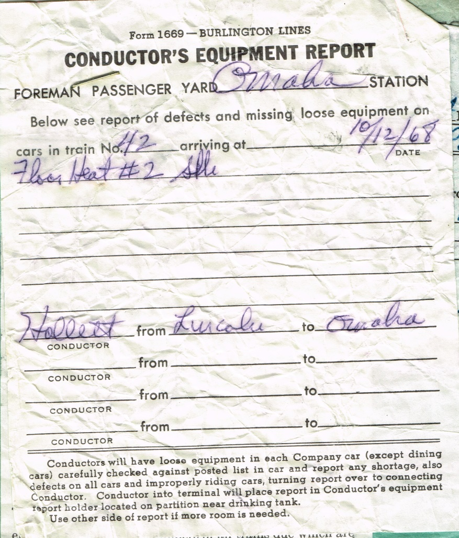
Form 1648 | 1968/10/12 | 0315 |  |  | Check of Train Register at Ravenna | Train 42 at 315 AM 10/12/1968  Train 43 arrived 315a with no signals
Clearance Form A | 1968/10/12 | 0347 | 42 |  | C&E No 42 at Ravenna | 4 orders: 7 652 666 620
Form 19 | 1968/10/12 | 0138 | 42 | 7 | C&E No 42 at Ravenna | NO 42 Eng 9936A meet Extra 950 West at Aurora
Form 19 | 1968/08/19 | 228 |  | 652 | C&E Eastward trains at Ravenna | Sidings at Hampton Abbott and St Michael blocked with cars
Form 19 | 1968/09/01 | 1428 |  | 666 | C&E Eastward trains via Hampton at Ravenna | At Emerald siding is blocked with cars
Form 19 | 1968/10/11 | 2119 |  | 620 | C&E Eastward trains via Hampton at Ravenna | At Pleasant Dale siding blocked with cars
Form 1648 | 1968/11/14 | 0305 |  |  | Check of Train Register at Ravenna | Train 42 at 305 AM 11/14/1968  Train 41 arrived 255a with no signals
Clearance Form A | 1968/11/14 | 0235 | 42 |  | C&E No 42 at Ravenna | 7 orders: 56 74 78 2 610 611 616
Form 19 | 1968/11/13 | 1654 | 42 | 56 | C&E No 42 at Ravenna  C&E Extra 963 East at Ravenna | Extra 963 East run ahead of No 42 CTC Ravenna to Cushman
Form 19 | 1968/11/13 | 2110 | 42 | 74 | C&E No 42 at Ravenna | NO 41 has right over No 42 Lincoln to CTC Ravenna
Form 19 | 1968/11/13 | 2231 | 42 | 78 | C&E No 42 at Ravenna | Extra 980 West has right over No 42 Cushman to Grand Island
Form 19 | 1968/11/14 | 0230 | 42 | 2 | C&E No 42 at Ravenna | NO 42 Eng 9942B meet No 77 Eng 567 at Seward
Form 19 | 1968/10/27 | 0001 |  | 610 | C&E Eastward trains at Ravenna | Sidings at Hampton Abbott and St Michael blocked with cars
Form 19 | 1968/10/27 | 0001 |  | 611 | C&E Eastward trains via Hampton at Ravenna | At Emerald siding is blocked with cars
Form 19 | 1968/10/27 | 0001 |  | 616 | C&E Eastward trains at Ravenna | Look out for holes in deck of bridge 117.31 east of St Michael account bridge repairs
Clearance Form A | 1968/11/15 | 0244 | 42 |  | C&E No 42 at Ravenna | 6 orders: 54 66 9 610 611 616
Form 19 | 1968/11/14 | 1920 | 42 | 54 | C&E No 42 at Ravenna  C&E Extra 910 East at Ravenna | Extra 910 East run ahead of No 42 CTC Ravenna to Cushman
Form 19 | 1968/11/14 | 2053 | 42 | 66 | C&E No 42 at Ravenna | NO 41 has right over No 42 Lincoln to CTC Ravenna
Form 19 | 1968/11/15 | 0234 | 42 | 9 | C&E No 42 at Ravenna | Extra 982 East run ahead of No 42 Grand Island to Aurora
Form 19 | 1968/10/27 | 0001 |  | 610 | C&E Eastward trains at Ravenna | Sidings at Hampton Abbott and St Michael blocked with cars
Form 19 | 1968/10/27 | 0001 |  | 611 | C&E Eastward trains via Hampton at Ravenna | At Emerald siding is blocked with cars
Form 19 | 1968/10/27 | 0001 |  | 616 | C&E Eastward trains at Ravenna | Look out for holes in deck of bridge 117.31 east of St Michael account bridge repairs

