Form | Date | Time | Train # | Order # | Recipient | Details
KCT Air Brake Clearance Card | 1968/01/12 |  | 21 |  | C&E No 21 | 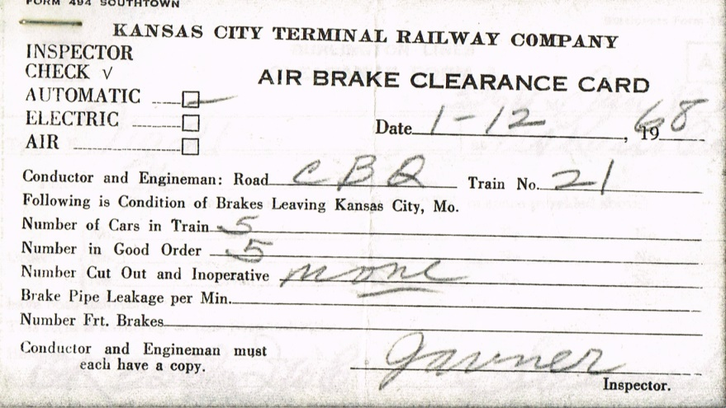
Clearance Form A | 1968/01/12 | 1556 | 21 |  | C&E No 21 at UD Kansas City | No orders
KCT Air Brake Clearance Card | 1968/02/12 |  | 23 |  | C&E No 23 | 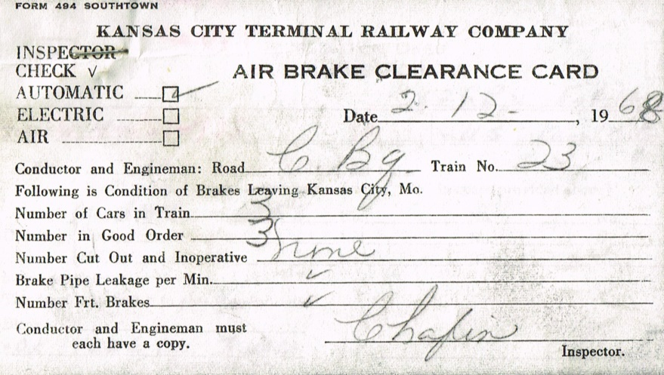
Clearance Form A | 1968/02/12 | 2256 | 23 |  | C&E No 23 at UD Kansas City | 2 orders: 544 558
Form 19 | 1968/01/31 | 1246 |  | 544 | C&E Northward trains at US Kansas City | Do not exceed 25 MPH over CRI&P crossing MP 45.92
Form 19 | 1968/02/12 | 0921 |  | 558 | C&E Northward trains at US Kansas City | Do not exceed 10 MPH over CGW crossing MP 27.36
KCT Air Brake Clearance Card | 1968/03/22 |  | 27 |  | C&E NO 27 | 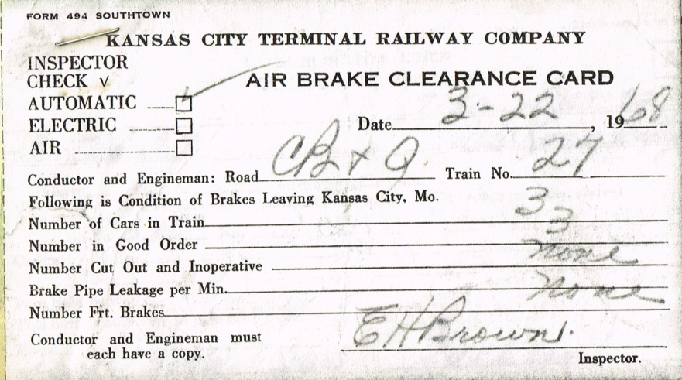
Clearance Form A | 1968/03/22 | 0715 | 27 |  | C&E No 27 at UD Kansas City | 1 order: 585
Form 19 | 1968/03/01 | 1403 |  | 585 | C&E Northward trains at US Kansas City | Do not exceed 25 MPH over north switch Sadler MP 34.90
Teletype Message | 1968/03/10 | 1333 | 27 |  | Condr No 27 US Kansas City | Ottumwa  Condr No 27 US Kan City March 22  Insurance Womens Assn 15 to 20 persons Eva Hartman in Charge leave Kans City N 27 Mar 22 to Omaha to return No 26 Mar 24  To occupy seats in Diner Lounge. Expect to eat breakfast on No 27 and Dinner on No 26 all concerned pls how special attention  HRD
Message | 1968/03/22 |  | 27 |  | C&E No 27 | Kansas City 22 1968  C&E No 27 Date  Stop at Ustick for 1 passenger
KCT Air Brake Clearance Card | 1968/04/22 |  | 27 |  | C&E No 27 | 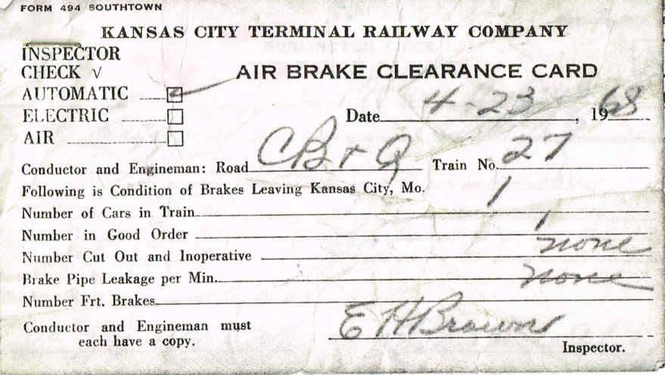
Clearance Form A | 1968/04/23 | 0746 | 27 |  | C&E No 27 at UD Kansas City | No orders
KCT Air Brake Clearance Card | 1968/06/25 |  | 27 |  | C&E No 27 | 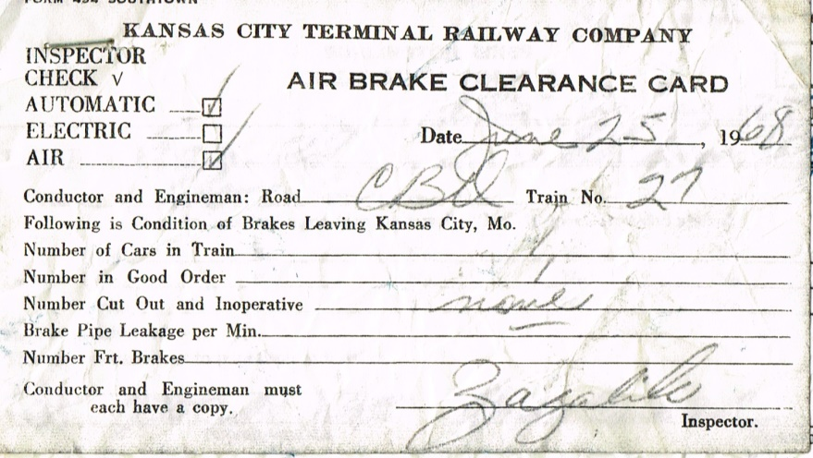
Clearance Form A | 1968/06/25 | 0735 | 27 |  | C&E No 27 at UD Kansas City | No orders
KCT Air Brake Clearance Card | 1968/07/22 |  | 27 |  | C&E No 27 | 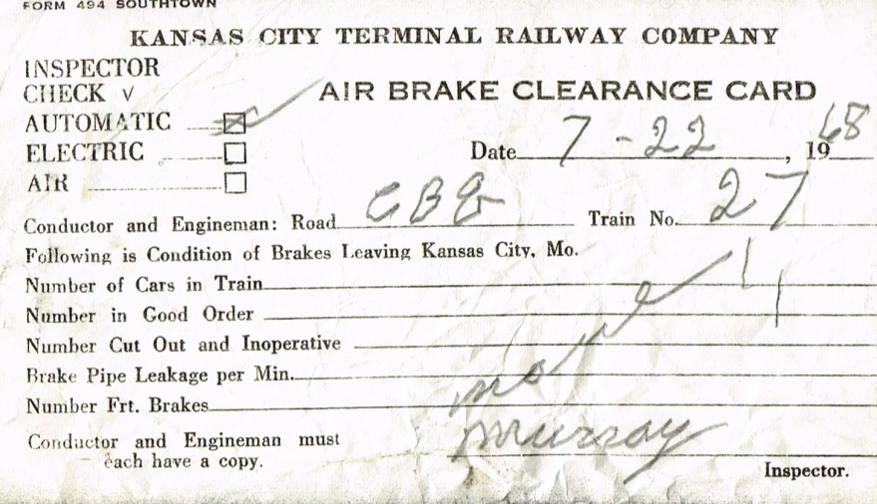
Clearance Form A | 1968/07/22 | 0725 | 27 |  | C&E No 27 at UD Kansas City | 1 order: 567
Form 19 | 1968/07/20 | 1202 |  | 567 | C&E Northward trains at US Kansas City | Chemical weed destroyer operated between Ustick and St Joseph rail may be slippery

