**Pullman Green Paint Chips**

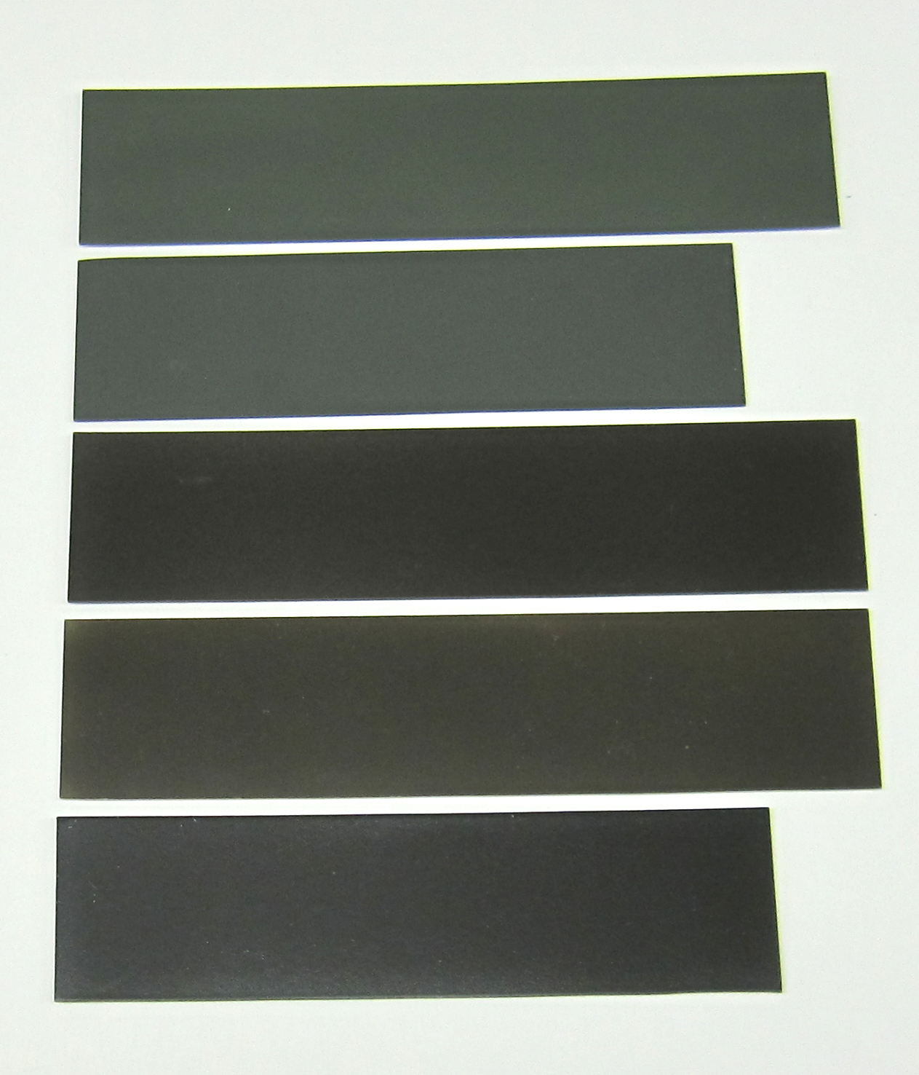

**Scalecoat II**

**Tru Color**

**Model Flex**

**Floquil**

**Poly Scale**